**Analysis of Network Traffic**

**Name:** Ayush Sharma

**Reg. No:** 15BCE1335

**Procedure:**

1. **Create some traffic on local host using hping3.**
2. TCP Packets

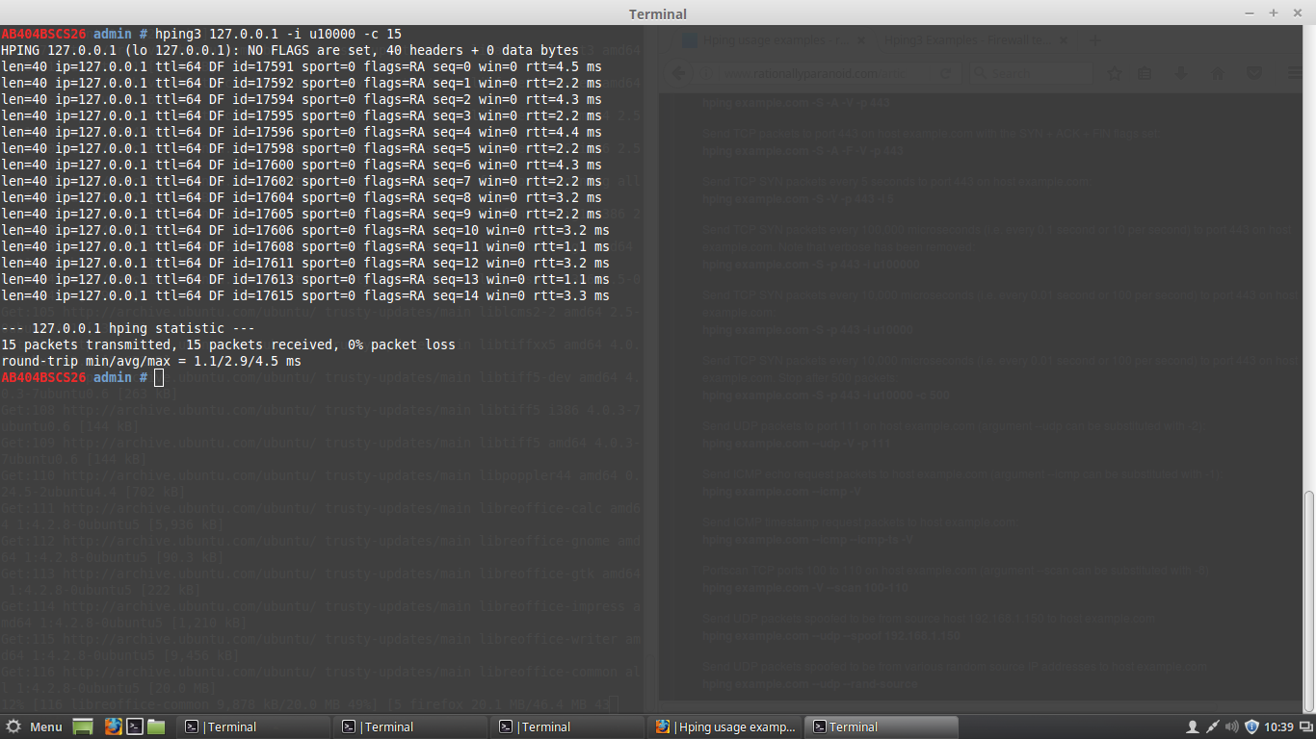

1. UDP Packets

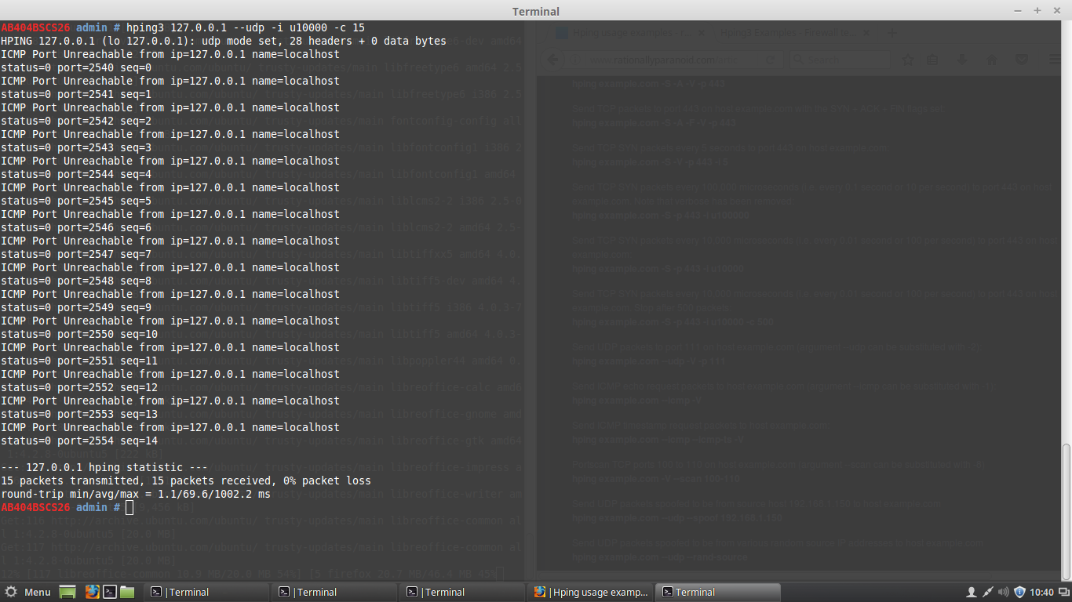

1. ICMP Packets

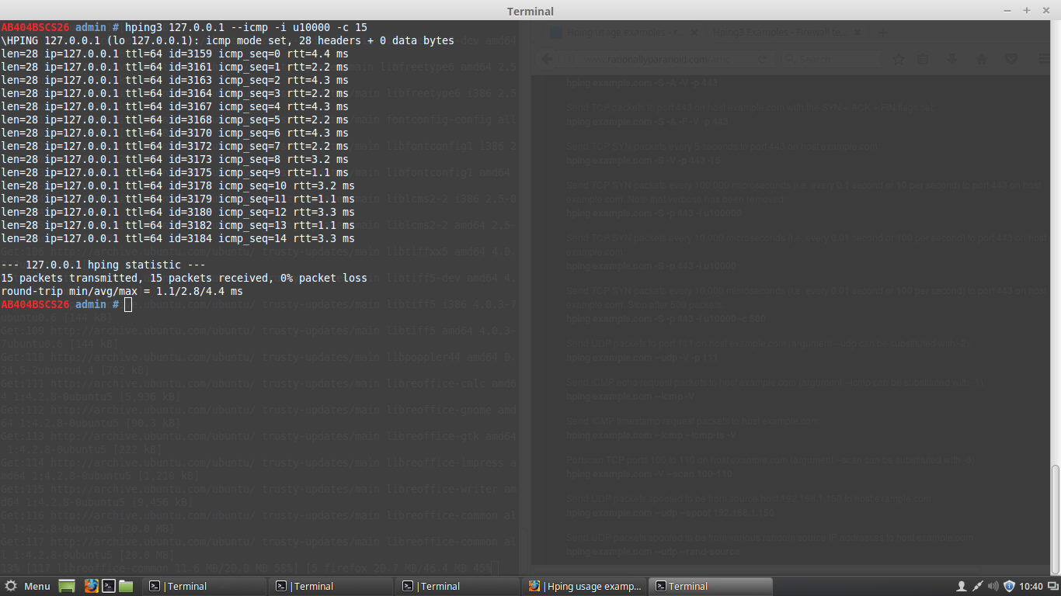

1. **Analyse the traffic using tshark**
2. TCP Packet

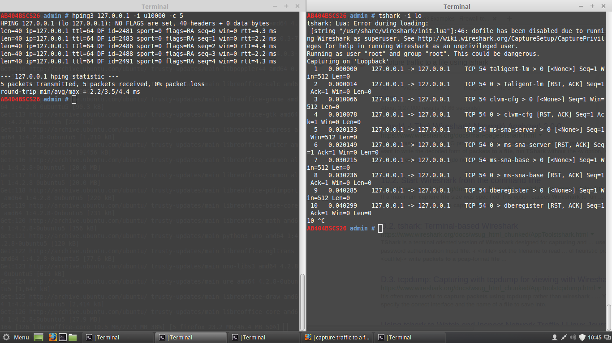

1. UDP Packet

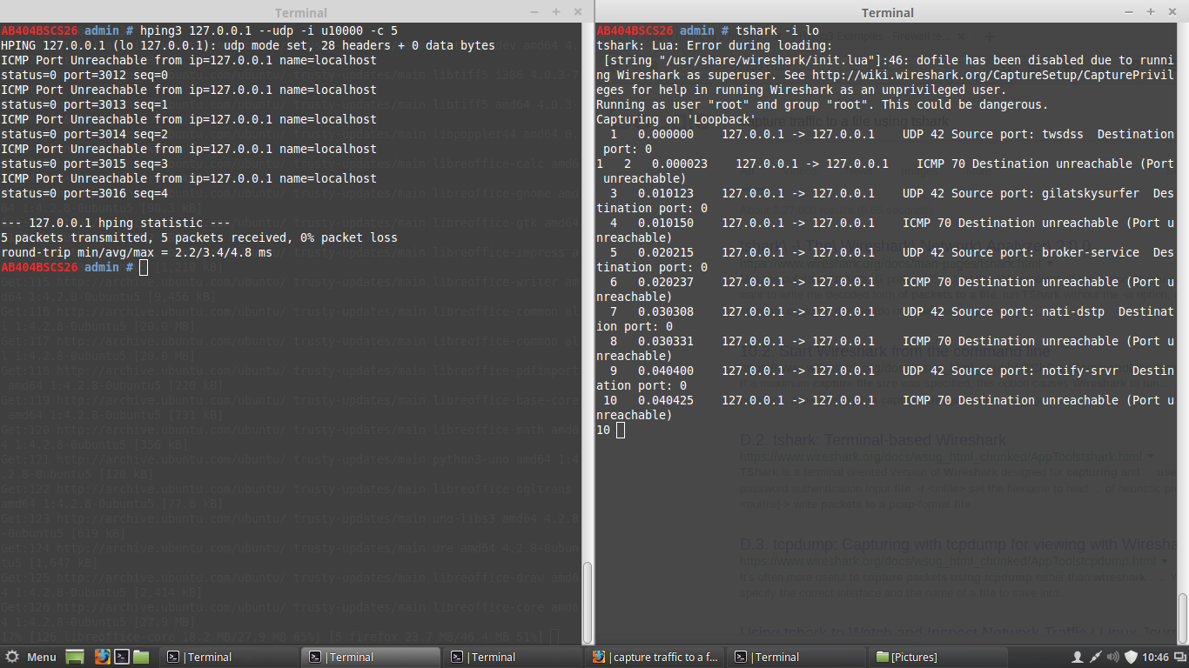

1. ICMP Packet

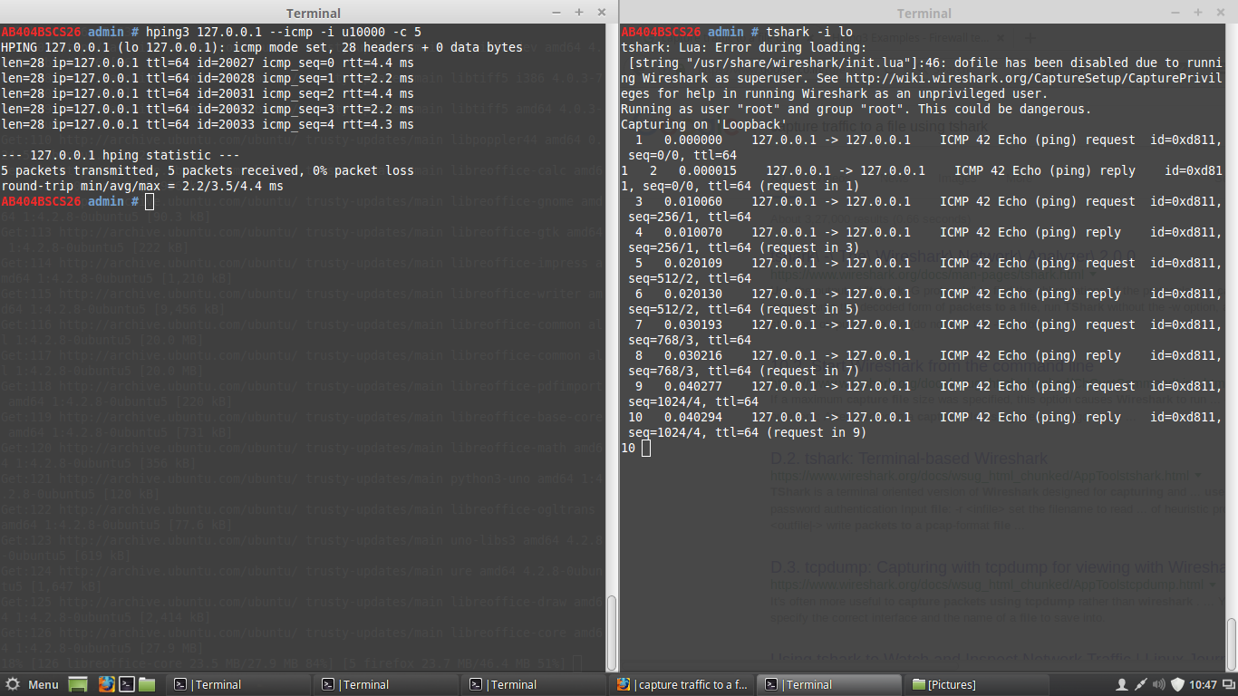

1. **Create a parsing function to count the number of lines in the file to verify the count of traced packets.**

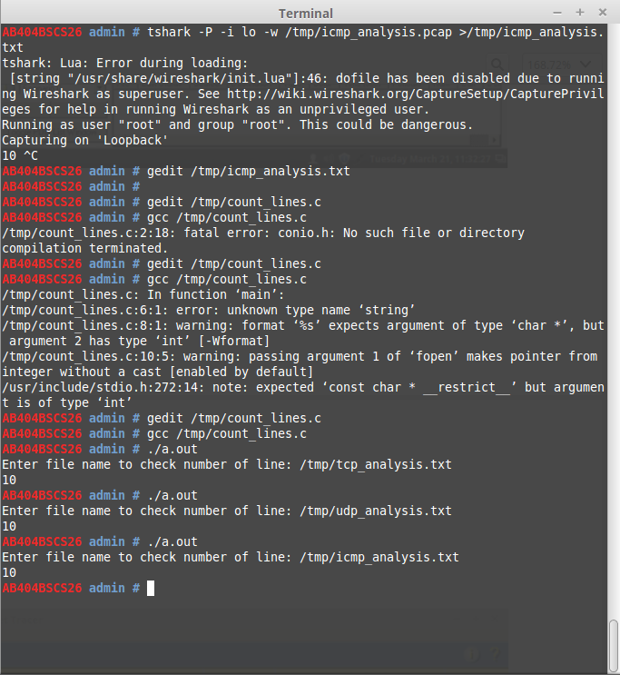

**#Note**: The number of lines is the double of packets send since it also counts the acknowledgement packets during pinging.